Name: Quang Huynh

Part I:

**KangHee Kim**

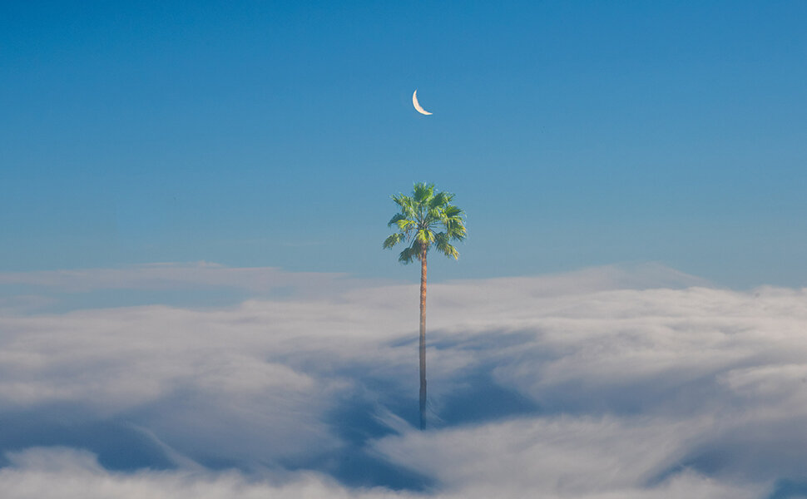

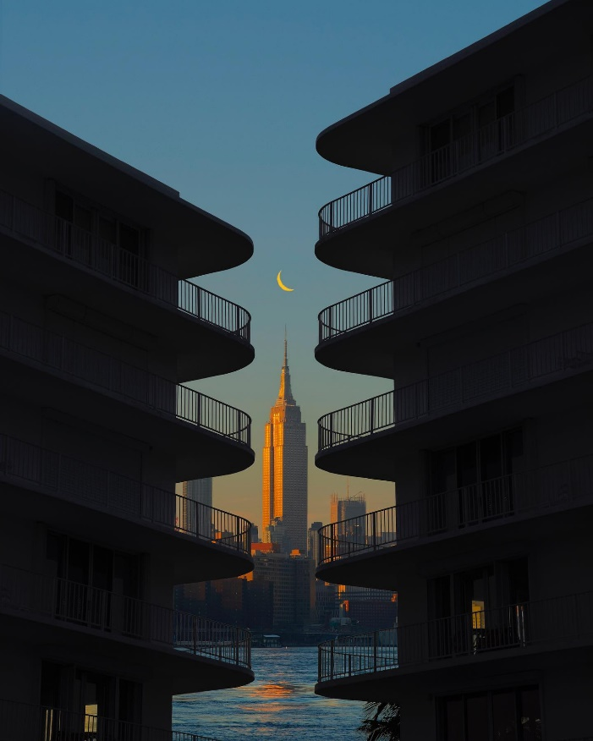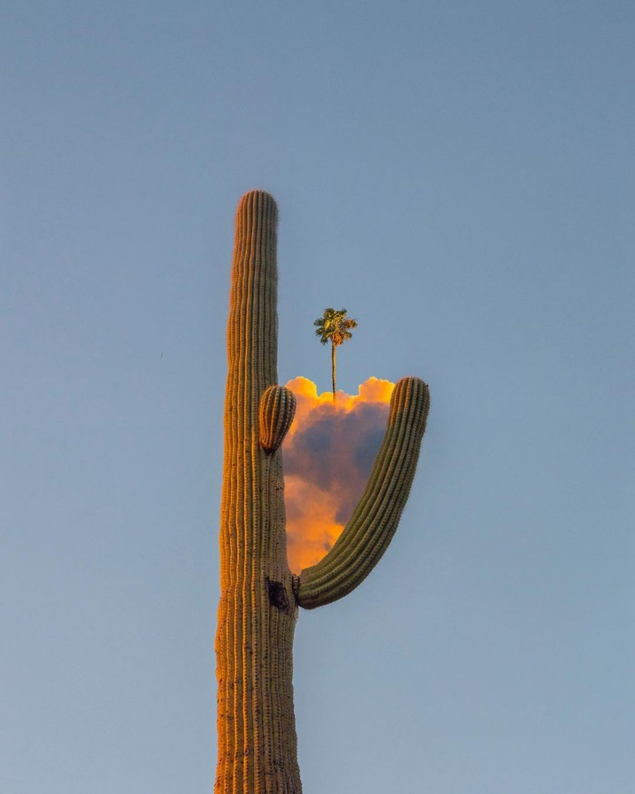

**Part II: Directions: answer the following questions about the piece you put above.**

**What about the artist drew you to him/her? What did you like about him/her?**

What really drew me to KangHee Kim was her use of coloring and framing in her work. Her art gives me a feeling of tranquility and calmness. This is because her art feels like a dream. Her photography can be described as dreamlike and surreal.

**What about the picture you included did you find intriguing or beautiful?**

Her images have a distinctive way of fusing reality and fantasy, frequently using multiple exposures, reflections, and altered perspectives. The distinction between reality and fiction is blurred in a way that is both thought-provoking and artistically gorgeous in KangHee Kim's art, which is distinctive and enthralling. Her talent as a photographer and her artistic perspective speak to her ability to elevate commonplace sights into something spectacular.

**Consider at least two of the elements of photography and discuss how they are illustrated in this picture above.** KangHee Kim uses color in a dramatic way in her works of art. Her pictures frequently have vivid, strong hues that jump off the paper and give off an otherworldly feeling. Her compositions usually include organic elements like flowers and trees, which adds to the surreal nature of her work. The use of framing by KangHee Kim is a crucial component of her photography. She frequently employs framing strategies to emphasize compositional aspects and give her pictures a sense of depth and perspective. The utilization of reflections is one of the framing strategies that KangHee Kim commonly uses. She may add a sense of depth and layering to her photos by taking them in front of a reflective surface like a window or mirror. The reflection serves as a frame inside a frame, focusing attention on the topic and generating aesthetic appeal.